Joseph Silva Jr.

SNHU

CS 405: 4-2 Milestone: Unit Testing

11/20/2021

**Original Code Debug Results**

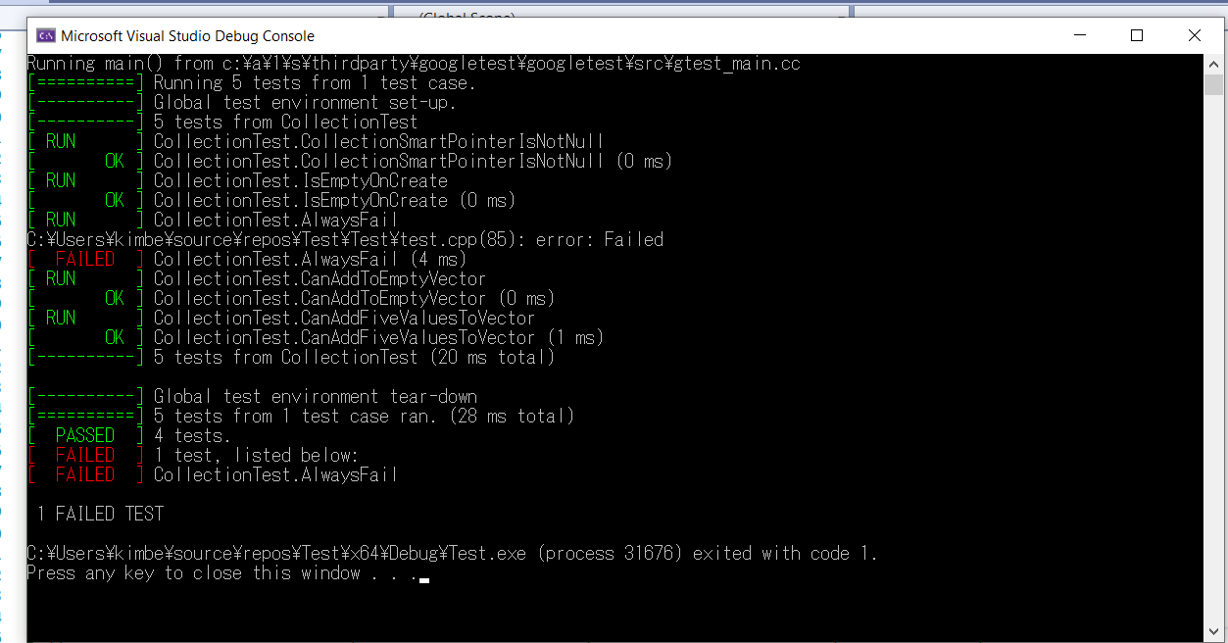

**Updated Code Debug Results**

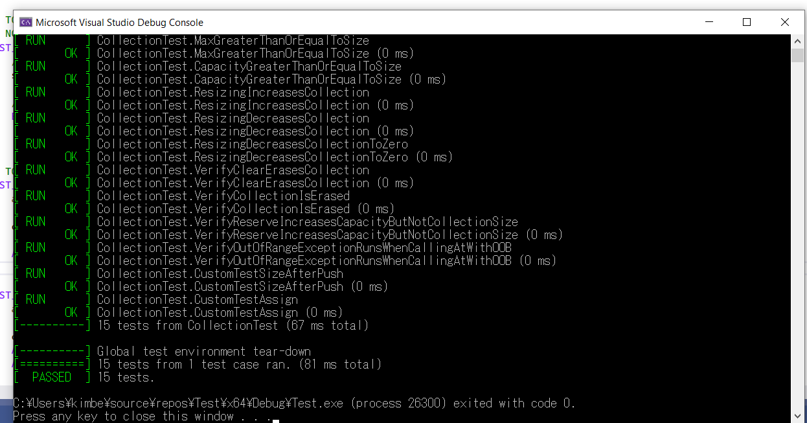

**Summary:**

Using Visual Studios 2022, I created a google test project and uploaded the provided cpp file. Without the Google Test Guide PDF, I think I would have had a difficult time finding the Google Test Project in VS because it was at the very bottom of the selections, and I have never used a Google Test Project before. In the project, I kept #include pch header file to keep the precompiled header files in the test. Without adding the tests on the TODO list, my program only ran 5 tests for the collectiontest. I commented out Test always fail command because it caused failures in the tests when running the program for collectiontest. I was able to reuse most of the code to create the tests by adding entries and verify if the entries were greater than the capacities and size.